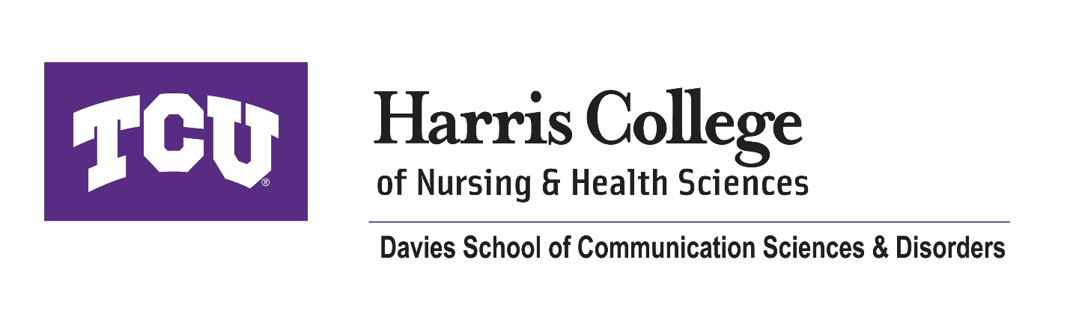
Vision: Improving the lives of all people with hearing, communication, cognitive, and swallowing disorders
Mission: The Davies School of COSD cultivates inclusivity and leads the field in
- Innovative education
- Impactful practice and community service
- Influential research

- Pillar #1 Student-Centered Growth
  - Goals
    - By 2035, the Speech, Language, and Hearing Sciences Bachelor’s program in the Davies School of COSD will increase enrollment to 195 students (average of 50 each cohort).
    - By 2035, the Speech-Language Pathology Master’s program in the Davies School of COSD will increase enrollment to 26 graduate students per cohort.
    - Starting in the 2025-2026 academic year, the Harris College PhD in Health Sciences program with an emphasis in COSD will enroll an average of 2 PhD students per cohort.
    - By 2035, the Speech-Language Pathology Master’s program in the Davies School of COSD will be ranked in the top 50 programs based on the US News and World Report.
    - By 2035, 50% of the undergraduate and graduate students will participate in research activities.
    - By 2035, undergraduate and graduate programs will offer an average of 5 research clinical opportunities to earn clinical hours or experiences
- Pillar #2 Research
  - Goals
    - Starting in 2025-2026, the rolling average of external funding within the department will be $500,000.
    - By 2035, the external grant submission portfolio of the faculty of the Davies School of COSD will include 30% new funding agencies.
    - By 2035, the Speech-Language Pathology Master’s program in the Davies School of COSD will be ranked in the top 50 programs based on the US News and World Report and top 4 in Texas.
    - By 2035, there will be a 50% increase in views and engagements on research-specific social media posts.
    - By 2035, all the research faculty in the Davies School of COSD will have a h-index greater than 10.
    - Starting in 2025-2026, the rolling average of peer-reviewed publications will be greater than 12 per year across the unit.

- Pillar #3 Community Engagement
  - Goals
    - By 2035, the Speech-Language Pathology Master’s program in the Davies School of COSD will be ranked in the top 50 programs based on the US News and World Report and top 4 in Texas.
    - By 2035, the Davies School of COSD will have established partnerships with at least 5 community members (e.g., schools, hospitals, community centers, private companies, philanthropic organizations).
    - By 2035, the Davies School of COSD will have more than one established benefactor.

